**Program using Selection statements: Set2**

Q1)

Write a program that calculates the user’s body mass index (BMI) and categorizes it as underweight, normal, overweight, or obese, based on the following table from the United States Centers for Disease Control:

BMI Weight Status

Below 18.5 Underweight

18.5–24.9 Normal

25.0–29.9 Overweight

30.0 and above Obese

Read the value for BMI weight from the user and display the corresponding category on the screen.

Q2)

The National Earthquake Information Center has asked you to write a program implementing the following decision table to characterize an earthquake based on its Richter scale number.

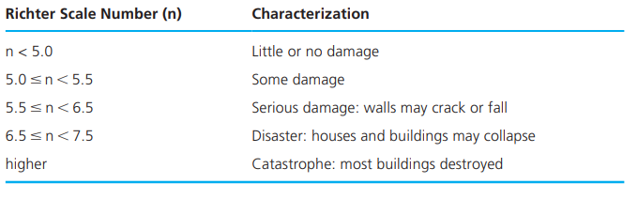

Q3)The consistency of a soil is usually determined through unconfined compression test on soil samples in labs. The consistency of a soil is usually dependent on the Shear Strength. The relationships between the two entities are given in the below table. Write a flowgorithm that accepts shear strength of a soil to decide its consistency.

|  |  |
| --- | --- |
| Shear Strength N/M2 | Consistency |
| Less than 24500 | Soft |
| Between 24500 and 49000 | Medium Stiff |
| Between 49000 and 98000 | Stiff |
| Between 98000 and 196000 | Very Stiff |
| 196000 and above | Hard |

Read Richter scale number as the user input and display the corresponding category on the screen.

Q4)

At last the first term at the University came to its finish. You have already passed all the exams and wants to know if you get a scholarship. There is the following practice of giving scholarship to students at the University:

* if a student has got satisfactory marks, the scholarship is not given
* if a student has passed through the examination with only excellent marks, he gets a personal scholarship
* if a student doesn’t get a personal scholarship and his average mark is not less than 4.5, he gets a high scholarship
* if a student gets neither high nor personal scholarship and doesn’t have satisfactory marks, he gets a common scholarship.

A satisfactory mark corresponds to value 3, a good mark corresponds to value 4, and an excellent mark corresponds to value 5. An average mark for a student is the average value of all the marks this student got in his exams. Write a program to find the type of scholarship given number of subjects and the marks in the subjects (marks should be between3 and 5).

A sample session follows.

Case1:

Enter the number of subjects: 3

Enter the marks: 5 5 4

Congratulations! You got a high scholarship

Case2:

Enter the number of subjects: 4

Enter the marks: 3 3 3 3

Oops! You are not eligible for a scholarship.

**Programs using switch case:**

Q1 Write a menu-driven program using Switch case to calculate the following: 1. Area of circle 2. Area of square 3. Area of sphere

Q2) [Write a C program to check whether an alphabet is vowel or consonant using switch case.](https://codeforwin.org/2015/06/c-program-to-check-vowel-or-consonant-using-switch-case.html)

Q3)[Write a C program to find maximum between two numbers using switch case.](https://codeforwin.org/2015/06/c-program-to-find-maximum-using-switch-case.html" \t "_blank)

Q4) Write a C Program to check positive negative or zero using switch case

# Q5) Write a C program to create calculator ( +: addition, - : substraction, \*-Multiplication, /: Division) using switch case

Q6)

write a C program that displays the following menu for the food items available to take order from the customer:  
• B= Burger  
• F= French Fries  
• P= Pizza  
• S= Sandwiches  
The program inputs the type of food and quantity. It finally displays the total charges for the order according to following criteria:  
• Burger = Rs. 200  
• French Fries= Rs. 50  
• Pizza= Rs. 500  
• Sandwiches= Rs. 150